`



SCSJ 1023: Technique Programming II

Lab Exercise 3

|  |  |
| --- | --- |
| NAME | MATRIX NO |
| AHMAD SYAFIQ BIN ANUAR | SX160093CSJS04 |

1. Code

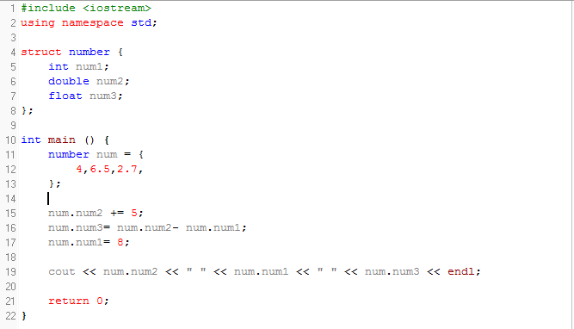

Output

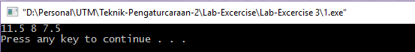

1. Code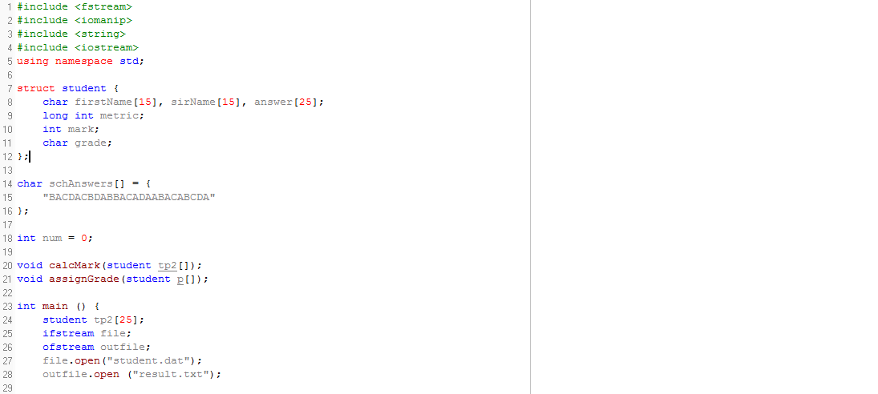

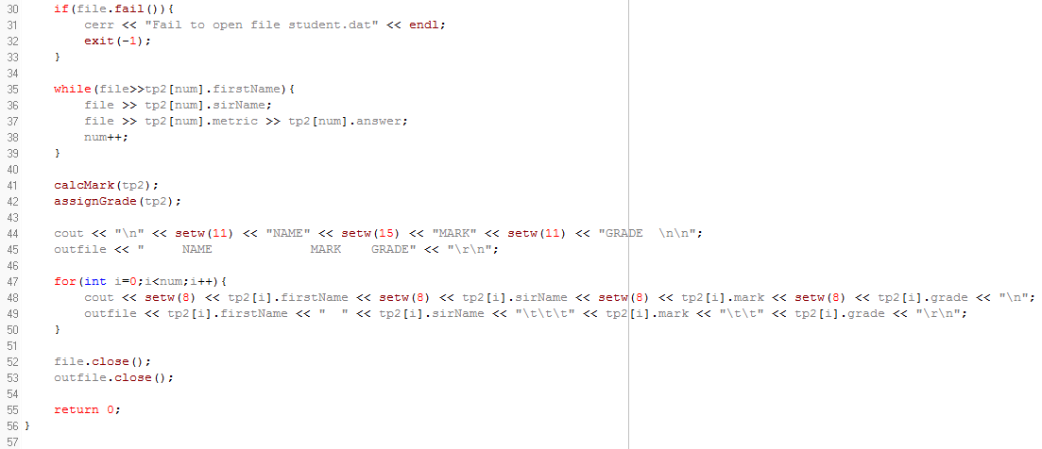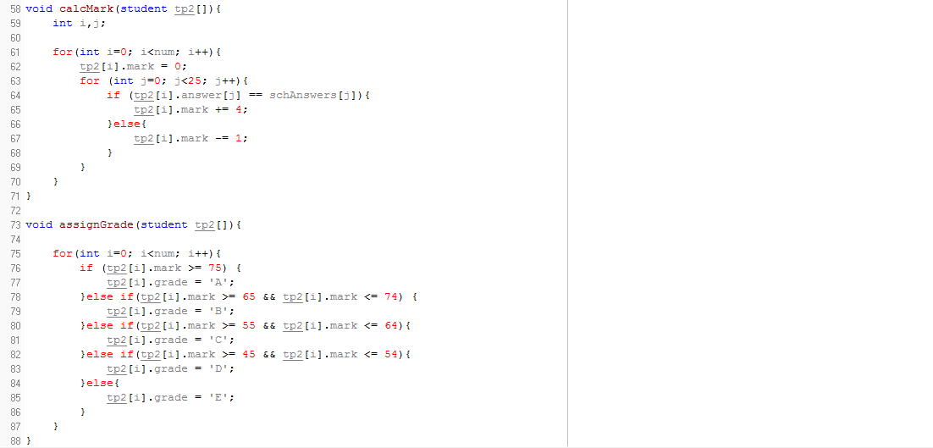

Output

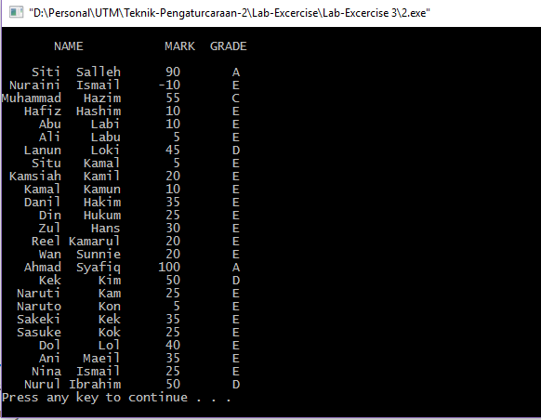

1. Code

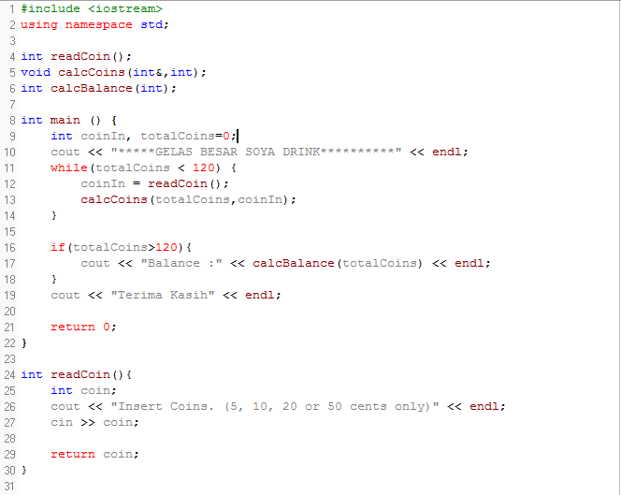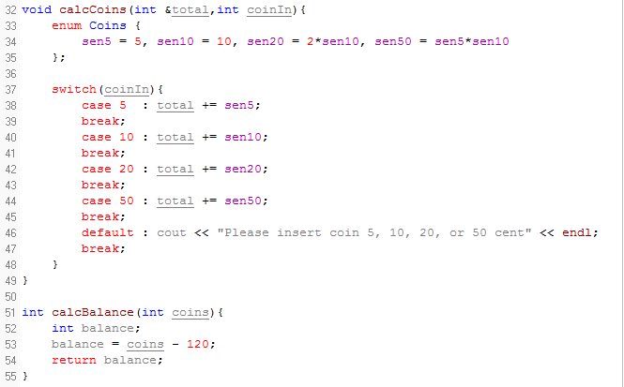

Output

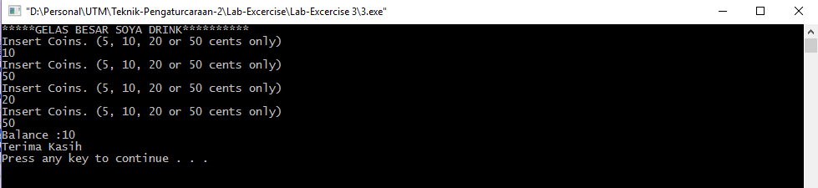

* 1. Code

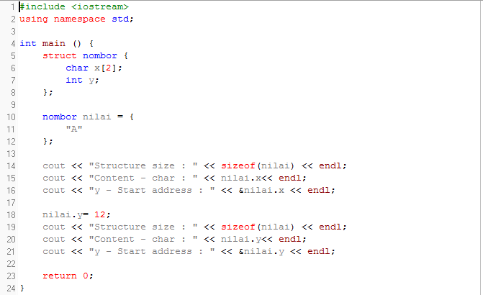

Output

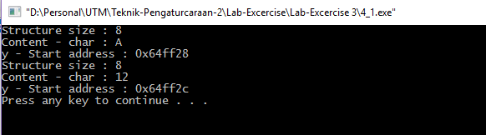

* 1. Code

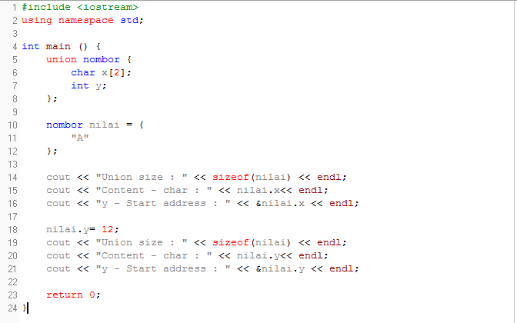

Output

